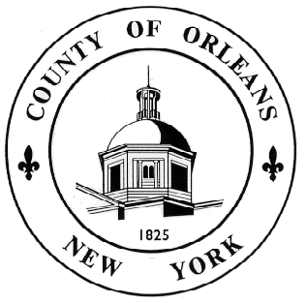
LYNNE M. JOHNSON
Chairman
WILLIAM H. EICK
Vice Chairman
JOHN C. WELCH, JR.
Chief Administrative Officer
LISA STENSHORN
Clerk of the Legislature
KATHERINE BOGAN
County Attorney
LEGISLATORS

Donald J. Allport | - At Large
E. John DeFilipps | - At Large
Merle L. Draper | - At Large
William H. Eick | - District 1
Lynne M. Johnson | - District 2
Fred Miller | - District 3
Kenneth DeRoller | - District 4

ORLEANS COUNTY LEGISLATURE
14016 Route 31 W, Suite 201, Albion, New York 14411
Phone: (585) 589-7053
Fax: (585) 589-1618
www.orleansny.com

FOIL REQUEST
Date of Request _______________
Name of Applicant (Please Print) ____________________________________________
Address_________________________________________________________________
Representing_____________________________________________________________
Daytime Telephone Number_________________________________________________
I hereby apply to _____inspect and/or ______ copy the following records:
________________________________________________________________________
_______________________________________________________________________ ________________________________________________________________________________________________________________________________________________________________________________________________________________________
I understand the Records Access Officer must respond to my request within five business days of receipt of written request by making the records available or by denying access in writing giving the reasons for denial or providing a written acknowledgment of receipt of my request and a statement of the approximate date when the request will be granted.
I also understand and acknowledge that I will be charged a fee of $0.25 per photocopy for documents up to 9” by 14” and a fee of $1.00 for certification. Fees for copies of other records will be based upon the actual cost of reproduction. Payment must be made at the time copies of records are provided.

Signature of Applicant _____________________________________________________

Return completed application to:
Email: April.Flesch@orleanscountyny.gov
By Mail: Orleans County Legislature
14016 Route 31 West, Suite 201
Albion, NY 14411
For Agency Use Only:

_____ Approved

_____ Denied for reason(s) checked below
_____confidential disclosure
_____part of investigatory files
_____unwarranted invasion of personal privacy
_____record of which this agency is legal custodian cannot be found
_____record is not maintained by this agency
_____exempted by statute other than the Freedom of Information Act
_____other (specify)

_______________________ ________________________ ___________________
Signature title date

Receipt:
Number of Copies received: . Cost per copy: . Total amount due: .
Cash/Check/Money Order received in the amount of $ , on this date: .
Make Checks/Money Order payable to: Orleans County Treasurer

NOTICE: You have a right to appeal a denial of this application to the head of this agency, who must fully explain his reasons for such denial in writing seven days of receipt of an appeal.

I HEREBY APPEAL:

____________________________________ ____________________
Signature date

